Installation Guide
Project Homerweb
v1.0
DVL Holdings
Team Homerweb (Georgia Institute of Technology)
Table of Contents

Introduction 3
General Requirements 3
Operating System 3
PHP 3
Apache 3
MySQL 3
GoDaddy Installation Instructions 3
Server Configuration 3
Creating a Database 4
Configuring SSH Login 6
Homerweb Installation and Initial Configuration 7
Uploading Homerweb to the Server 7
Configuring the Database 7
Configuration 9
Account Creation 9

Introduction
There are many different ways one could go about installing this application. The bare requirements are to have a web server with Apache and PHP installed and also a database server (possibly the same computer as the web server) with MySQL installed. For the sake of brevity, this guide will show how to install and configure Homerweb on a GoDaddy Linux hosting account. If using another hosting provider, please refer to the following installation requirements.

General Requirements

Operating System
Homerweb has been tested and works on both Windows and Linux operating systems. While there has been no testing done, it should also work fine on Mac OSX. Either way, the computer must be public facing, that is it must have a public IP address and accessible from the Internet and have port 80 open on any firewalls.

PHP
PHP is a scripting language commonly used for writing web applications. It is required for at least PHP5 to be installed on the server.

Apache
Apache is a web server which delivers content that is stored on the server to web browsers access the Internet.

MySQL
A MySQL database server is required to store user and course information. It can be on the same server as apache or another one as long is it is accessible over the network. There needs to be a MySQL database created on the server called “cs4911” and also an account which has privileges.

GoDaddy Installation Instructions

Server Configuration
After creating a GoDaddy hosting account, log into the Hosting Control Center. You should be presented with a page similar to the following:
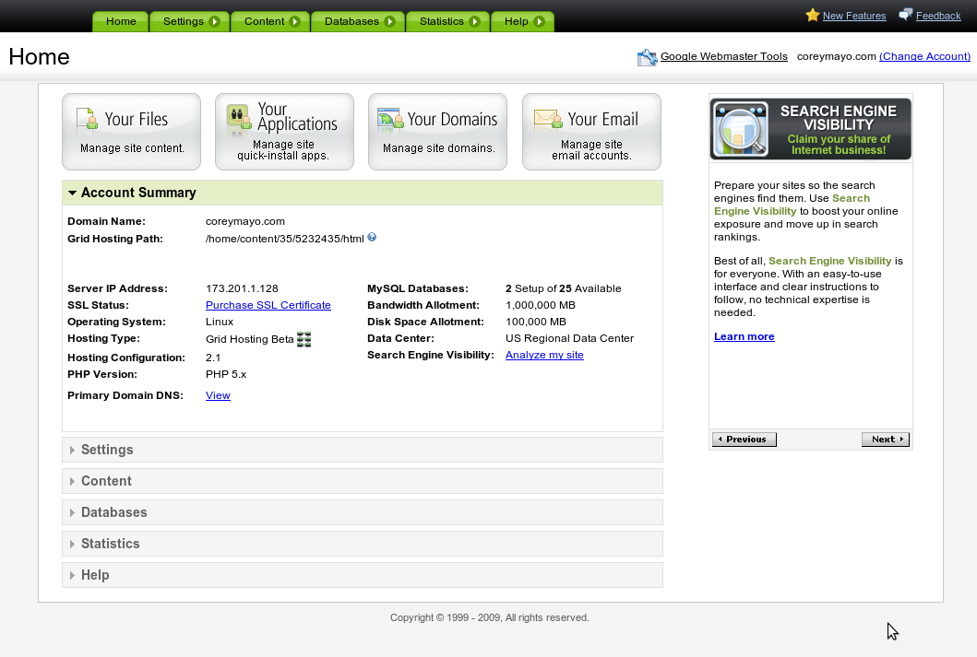Illustration 1: Main view of the GoDaddy hosting control center.
Before installing the application, there are several things that will have to be setup and configured using this site. First off is to create a MySQL database.

Creating a Database
From the main menu, click on the Databases sub menu, then click MySQL. This will bring you to a new page where you can create and manage individual databases.
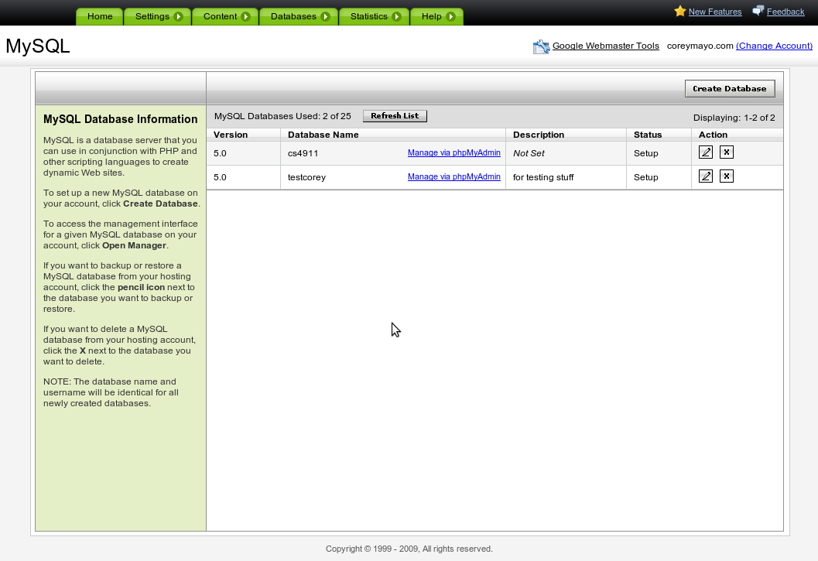Illustration 2: GoDaddy MySQL management
Click on the button in the top right hand portion of the page labeled Create Database. This will bring you to a new page where you can specify several different settings for the new database.
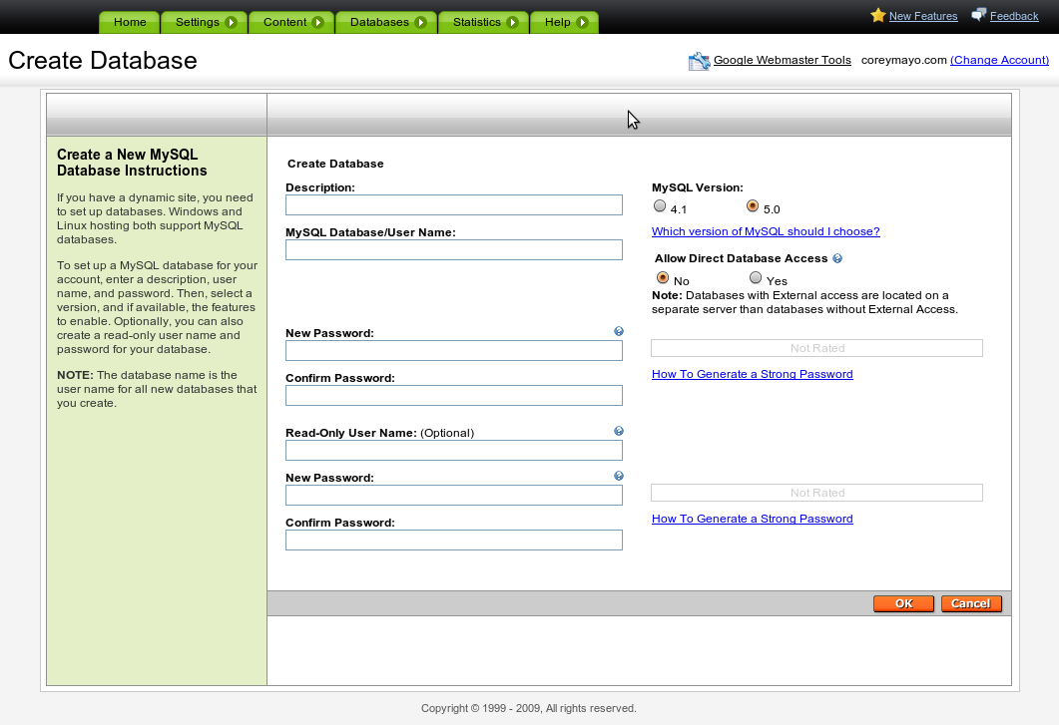Illustration 3: Create new database window
Keep all the defaults except for MySQL Database/User Name type in a name such as homerweb and also create a new password. After clicking OK, you will be brought back to the previous page with a new row for the new database. If the status says Pending Setup, you will need to wait a few minutes then refresh the page until it says Setup. After the status changes to Setup, click the pencil in the right most column and note the Host Name which the database is hosted on (Note: this can sometimes take 30 minutes or more). You will need this user name, password, and host name later when configuring Homerweb.

Configuring SSH Login
To upload the Homerweb application to the site, you will have to first configure SSH login. In the main hosting control center page, select the settings menu, then click SSH. You will now need to create credentials to log in via SSH. Remember this as you will need it to upload files later.

Homerweb Installation and Initial Configuration

Uploading Homerweb to the Server
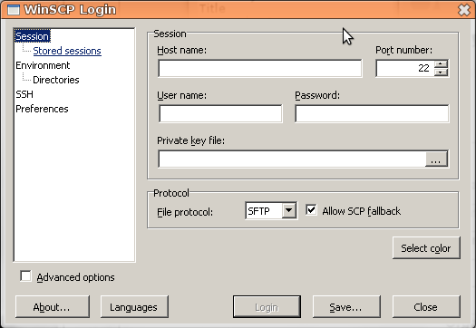Illustration 4: WinSCP Login
You will now need to login using a SFTP client. One that is recommended for Windows computers is WinSCP. After installing this on your computer, you will need to connect to the server. Run WinSCP, and you will be presented with a dialog like the following:
In this login dialog, you will need to specify the host name, user name, and password. For the host name, use the domain name you have registered to your GoDaddy account. For the user name and password, use the user name you have associated with your GoDaddy account and the password you supplied when configuring the SSH login.
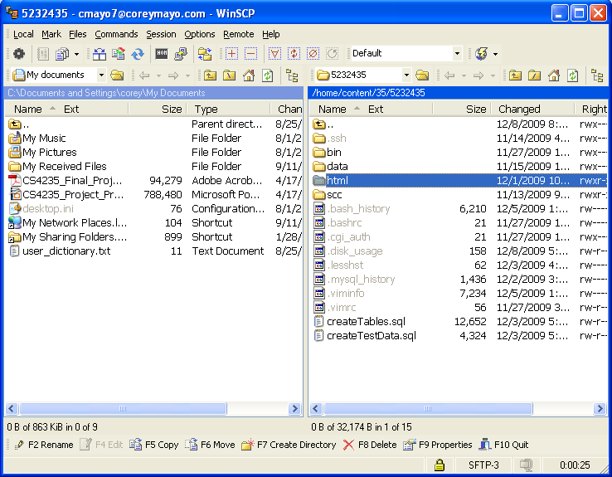Illustration 5: WinSCP directorey listing
After entering these settings, click Login. You will then be brought to a new window showing a directory tree of files on both your computer and the server.
You will now need to upload the Homerweb code to the server. In the left panel, browse to where you have saved the code. Copy the topmost directory of code (it should be called hoemrweb and its subdirectories should include application) to the html directory on the server.

Configuring the Database
After uploading the files, you will need to set up the database. This will be done by using the tools provided by GoDaddy. Back at the hosting control center main page, click on the Databases menu then click MySQL. Click on the link labeled Manange via phpMyAdmin to manage the database. You will then need to login using the database user name and password you supplied earlier. You will be presented a page similar to the following:
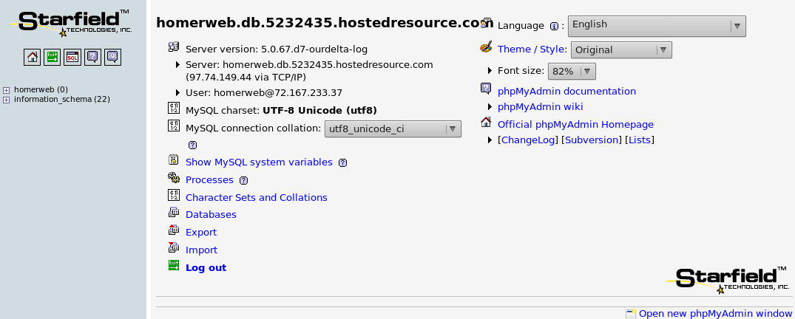Illustration 6: Main phpMyAdmin page
In order to configure the database, you are going to run two scripts. The first one will create all necessary tables, and the second will will create some basic data and a default site administrator account.
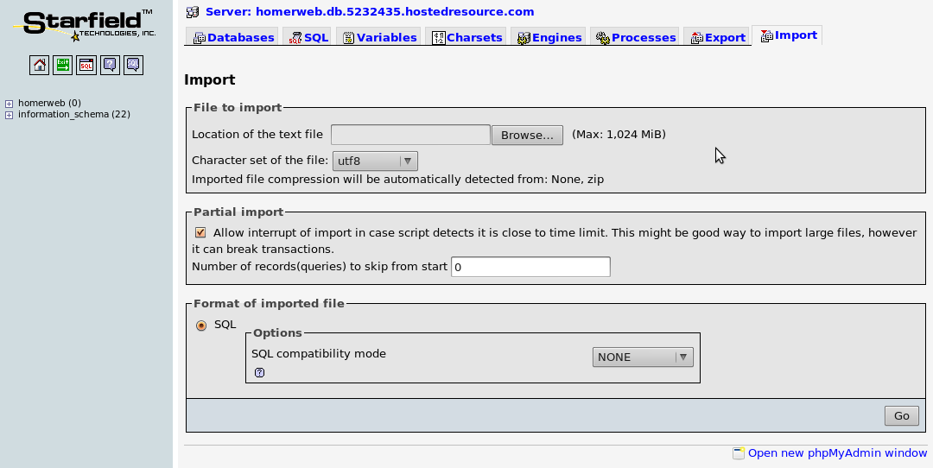Illustration 7: phpMyAdmin Import Page
In order to run the first script, click Import near the bottom (immediately above Log out). Next, browse to the location of the createTables.sql file stored on your computer (it is inside the homerweb directory) and click Go. This will create all necessary database tables for the program. Next, you will do the same procedure for the createAccounts.sql file in order to create a default site administrator account.

Configuration
Next you will have to edit a few files to configure some settings. Back in WinSCP, browse to the html/homerweb/application/config/ directory on the server. Double click the file called config.php. This should load the file in a text editor. You will need to change the base_url setting to that for your site's domain name. Save and close that file, and then click on the database.php file. Again, this file will open in a text editor, and you will need to edit the database hostname, username,and password, and database settings to match those that you noted earlier when creating the database. After saving this file, you have completed the installation of homerweb.

Account Creation
After completing the above steps, open your web browser to the the address http://yousitesurl.com/homerweb using the domain name for your site. You should be brought to the login page for homeweb. If so, congratulations, you should now login with the default username default@test.com and password blue1234 then change the password.

